**DATA DEFAULT NON TUNE**

Classification Report:

precision recall f1-score support

Benign 0.96 0.97 0.97 36837

Phishing 0.86 0.83 0.84 7966

accuracy 0.95 44803

macro avg 0.91 0.90 0.90 44803

weighted avg 0.94 0.95 0.94 44803

AUC-ROC: 0.9663

Accuracy: 0.9450

Precision: 0.9443

Recall: 0.9450

F1 Score: 0.9446

Testing Time: 42.13 seconds

Metrics Summary:

Accuracy: 0.9450

Precision: 0.9443

Recall: 0.9450

F1 Score: 0.9446

AUC-ROC: 0.9663

Testing Time (s): 42.1285

**DATA DEFAULT TUNE**

Classification Report:

precision recall f1-score support

Benign 0.98 0.98 0.98 36837

Phishing 0.90 0.89 0.89 7966

accuracy 0.96 44803

macro avg 0.94 0.93 0.94 44803

weighted avg 0.96 0.96 0.96 44803

AUC-ROC: 0.9839

Accuracy: 0.9627

Precision: 0.9625

Recall: 0.9627

F1 Score: 0.9626

Testing Time: 99.81 seconds

Metrics Summary:

Accuracy: 0.9627

Precision: 0.9625

Recall: 0.9627

F1 Score: 0.9626

AUC-ROC: 0.9839

Testing Time (s): 99.8131

**DATA SMOTE NON TUNE**

Classification Report:

precision recall f1-score support

Benign 0.83 1.00 0.91 36837

Phishing 0.94 0.04 0.07 7966

accuracy 0.83 44803

macro avg 0.88 0.52 0.49 44803

weighted avg 0.85 0.83 0.76 44803

AUC-ROC: 0.7645

Accuracy: 0.8283

Precision: 0.8474

Recall: 0.8283

F1 Score: 0.7571

Testing Time: 38.92 seconds

Metrics Summary:

Accuracy: 0.8283

Precision: 0.8474

Recall: 0.8283

F1 Score: 0.7571

AUC-ROC: 0.7645

Testing Time (s): 38.9189

**DATA SMOTE TUNE**

Classification Report:

precision recall f1-score support

Benign 0.89 0.99 0.94 36837

Phishing 0.91 0.45 0.60 7966

accuracy 0.89 44803

macro avg 0.90 0.72 0.77 44803

weighted avg 0.90 0.89 0.88 44803

AUC-ROC: 0.8643

Accuracy: 0.8947

Precision: 0.8962

Recall: 0.8947

F1 Score: 0.8798

Testing Time: 22.42 seconds

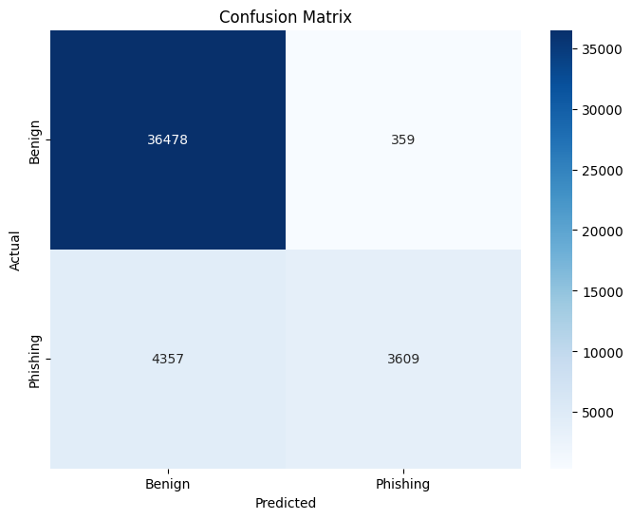

Metrics Summary:

Accuracy: 0.8947

Precision: 0.8962

Recall: 0.8947

F1 Score: 0.8798

AUC-ROC: 0.8643

Testing Time (s): 22.4209